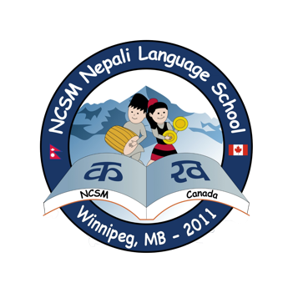
Schedule: Every Saturday from 10:00 am - 12:00 pm Venue: St Anne's Hindu Mandir
MONTH | DATE | CLASS# | Remark
SEPTEMBER | 1 | NO SCHOOL | Labor Day long weekend
 | 7 | 1
 | 14 | 2
 | 21 | 3
 | 28 | 4
OCTOBER | 5 | NO SCHOOL | NCSM Dashain Party
 | 12 | NO SCHOOL | Thanksgiving Day long weekend/Vijaya Dashami
 | 19 | 6
 | 26 | 7
NOVEMBER | 2 | 8 | Special program - Deusi (Next day is Bhaitika)
 | 9 | NO SCHOOL | Remembrance Day long weekend
 | 16 | 9
 | 23 | 10
 | 30 | 11
DECEMBER | 7 | 12
 | 14 | 13
 | 21 | 14
 | 28 | NO SCHOOL | Christmas/Winter
JANUARY | 4 | NO SCHOOL | Christmas/Winter
 | 11 | 15
 | 18 | 16
 | 25 | 17 | Semester I report card go home
FEBRUARY | 1 | 18
 | 8 | 19
 | 15 | NO SCHOOL | Louis Real Day long weekend
 | 22 | 20
MARCH | 1 | 21
 | 8 | 22
 | 15 | 23
 | 22 | 24
 | 29 | 25
APRIL | 5 | NO SCHOOL | Spring Break
 | 12 | 26
 | 19 | NO SCHOOL | Good Friday long weekend
 | 26 | 27
 | 3 | 28
MAY | 10 | 29
 | 17 | NO SCHOOL | Victoria Day Long weekend
 | 24 | 30
JUNE | 7 | 31
 | 14 | 32 | Semester II report card go home
 | 21 | 33 | Year End Program
Nepali Cultural Society of Manitoba (NCSM)
Nepali Language School
School Calendar: 2024-2025

